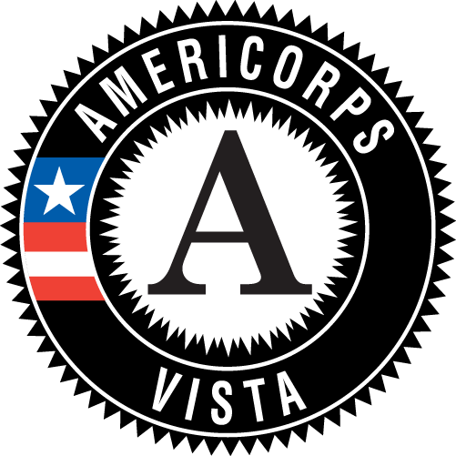
VISTA Summer Associates Handout

`

AmeriCorps VISTA

The mission of AmeriCorps VISTA (Volunteers in Service to America) has not changed since mandated by Congress in 1964, “AmeriCorps VISTA builds permanent infrastructure in non-profit organizations to help them more effectively bring individuals and communities out of poverty.” For over 40 years members have actively served in low-income areas by mobilizing people, businesses and organizations with the goal of creating sustainable healthy communities.

AmeriCorps VISTAs members leverage human, financial, and material resources to increase the capacity of thousands of low-income areas across the country to address challenges and improve their lives and communities.

Summer Associates Program Service

The VISTA Summer Associate program is a short-term service opportunity.
The Summer Associate program enhances an existing VISTA project or projects in the application stage by providing individuals that will participate for 8 to 10 weeks, alongside year-round VISTAs, in an intensive level of summer service. During service, Summer Associates are available to the community on a full-time basis which is described by Congress as “24 hours a day, 7 days a week.” This means that a Summer Associate should be available as deemed necessary by the sponsoring agency, for the project, without regard to standard working hours.

Summer Associate Members
As a Summer Associate, your contributions will have an actual and credible impact on those being served. The Project Supervisor will provide Summer Associates with a work plan which will detail the specific project and contribution.

Overview of Benefits and Support

In addition to making a credible effort to help people and communities escape poverty, Summer Associates receive benefits and support during and after successful completion of summer service.

As a Summer Associate, you are eligible to receive:

- A $1,174.60 Segal AmeriCorps Education Award or $125/month end of service cash stipend
- On-site orientation and training
- A living allowance to cover necessities during service
- AmeriCorps eCommunity and Alumni Network participation

Segal AmeriCorps Education Award

AmeriCorps VISTA Summer Associates are eligible to receive a $1,174.60 Segal AmeriCorps Education Award. The non-transferable award may be used at a qualifying educational institution (Title IV schools) or used to repay federal government backed student loans. This award counts as one of two education awards, that by law, a person can receive for AmeriCorps service in a lifetime. For more information, please visit www.americorps.gov.

Finances

AmeriCorps VISTA Summer Associate service is a short-term service opportunity; it is not employment. The Summer Associates receive a small subsistence allowance and should evaluate their financial situation to ensure that they are able to complete the full summer term. The Associate cannot have a part-time job or be employed in any other paid position during the term of service.

Subsistence/Living Allowance
The Corporation for National and Community Services provides a living allowance to cover the cost of food, housing, and other basic necessities during service. The allowance is low because a Summer Associate is expected to live at approximately the same economic level as the people in which they serve.

Summer Associates receive the living allowance every two weeks. While federal taxes are deducted from this allowance, state and social security (FICA) taxes are not deducted and become the responsibility of the Summer Associate. The allowance is deposited directly into the Summer Associate’s bank account.

Earned Income Credit
Earned Income Credit (EIC) is an amount that Associates may be able to have withheld from federal taxes taken from their living allowance. Eligibility is determined by the Internal Revenue Service (IRS). Refer to www.irs.gov for more information.

Income Exclusion
The living allowance of Summer Associates cannot be used in calculating benefits for public assistance programs if the Associate was eligible for and/or receiving benefits prior to joining AmeriCorps VISTA.

Delinquent Federal Debt
The U.S. Treasury Department collects delinquent debt owed through The Treasury Offset Program. This program automatically reduces amounts of federal payments, including the subsistence/living allowance and travel reimbursements, made to individuals who have delinquent federal debt. The reduced payment offsets the debt. For more information, visit www.fms.treas.gov.

Other Allowances
Summer Associates do not receive childcare support, relocation allowances, health benefits, or life insurance.

Leave

Annual and Sick Leave
Due to the short-term nature of this opportunity, there is no paid annual or sick leave.

Emergency Leave
- Summer Associates are eligible for leave up to five workdays for a death or critical illness in the immediate family; additional time requires the approval of the State Program Director
- Summer Associates are subject to jury duty; if called, the time spent on jury duty will not be counted against the term of service or educational award

Prohibitions and Limitations of Service

Full and Part-Time Employment is Prohibited
Summer Associate service requires a full immersion in the project and community.

Religious and Political Activities
Summer Associates may not use the VISTA title or authority while participating, influencing, or attending a political activity. A VISTA may not participate in political activities where she/he could be identified or apparently identified as an AmeriCorps VISTA member.

Summer Associates may not give religious instruction, conduct worship services, or engage in any other religious activity as part of their AmeriCorps VISTA duties that would be perceived as part of their duties by members of the community in which they serve.

Other Compensation
AmeriCorps VISTA Summer Associates and project sponsors are prohibited from requesting or receiving any compensation for the services of members.

For More Information

Contact Tom Sexton, Community Project Coordinator, Headwaters.
tom@kyheadwaters.org
606-634-8386

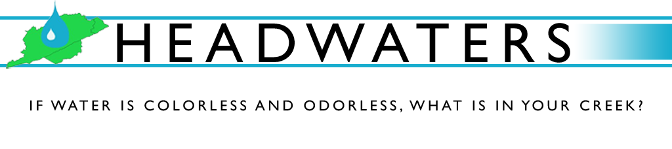Headwaters is a non-profit organization in Letcher County Kentucky that began five years ago as an entity to promote the interest of water quality in the area. Headwaters promotes partnerships among volunteers of the Kentucky River Watershed Watch, Big Sandy Watershed Watch, Upper Cumberland Watershed Watch, students of the local high school, community members and leaders, and government officials of Letcher County. Our mission is to improve the watersheds in Letcher County by educating the community, providing accurate and timely information, and instilling a sense of personal and community responsibility.

SUMMER ASSOCIATE APPLICATION
After you have reviewed the handout, please fill out the information below—be sure to print clearly and legibly in blue or black ink or, complete the application in Microsoft Word using a clean 12-point font. Your application must be received by no later than Thursday, May 15th to be considered. You can print the application out and mail it to us at: Headwaters, Inc. attn: Summer Associate Program, P.O. Box 1422, Whitesburg, KY 41858 (if you choose this option, please allow your application enough time to arrive before the deadline) or, to save time and postage, you can complete the application and e-mail it to us at: team@kyheadwaters.org.
Name:
Address:
Phone Number: ( ) -
Essay Questions
- Part of our mission at Headwaters, Inc. is to work to improve watersheds in Letcher County by “instilling a sense of community and personal responsibility.” In the space provided, please tell us how you would define community and personal responsibility regarding water quality issues.

- At Headwaters, we believe healthy watersheds are vital to economic growth and opportunity— especially in rural communities like ours. In the space below, identify and explain some ways that you think proper watershed management can provide economic opportunities for communities.

